**Stop Entry Techniques For Long Term Traders**

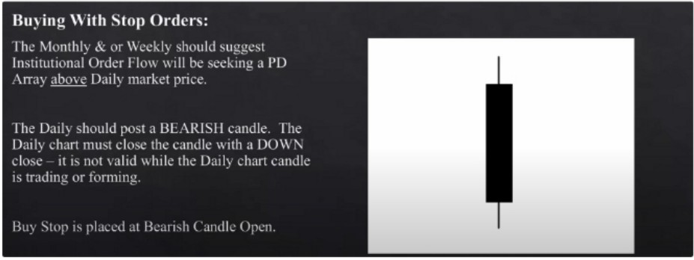

Open-

Close-

High



Low

--- **Entry Buy Stop Here**

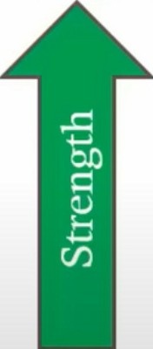

This would be a daily orderblock, we should be trading higher after it forms

Use this entry technique at HTF PD arrays, daily PD arrays

Everytime a new downcandle forms we move the buy stop to the new downcandle

When price moves away from the open and comes back down, you can look to be a buyer again with confirmation. But only if youve already taken profit. You can put the same position size you took partials on

The higher we get and closer we get to the monthly and weekly objectives/PD arrays the less likely that these candles will promote buying, so be careful of that. We preferably want to buy at EQ or below

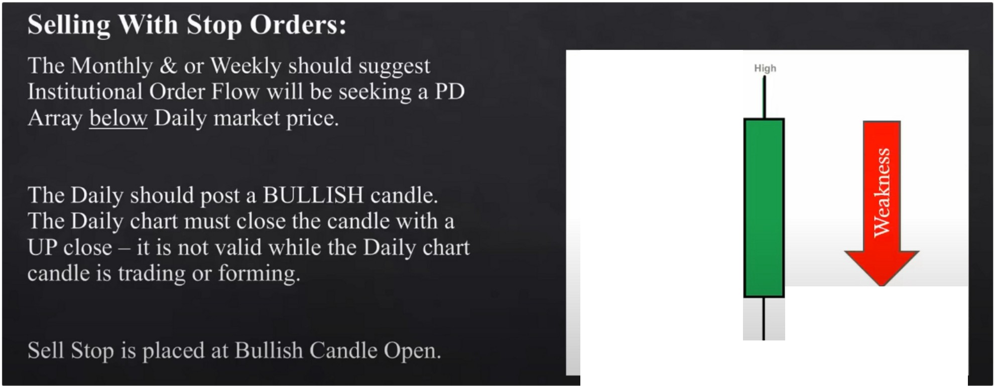

**Close +**

**Open---+**

- **Entry Sell Stop Here**

**Low**

The opening price a lot of the times it isnt traded back to

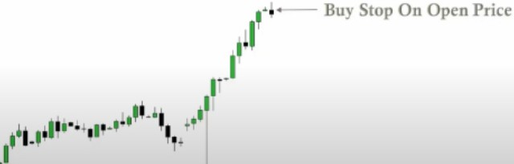

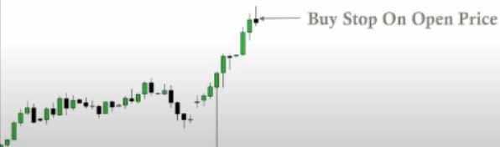

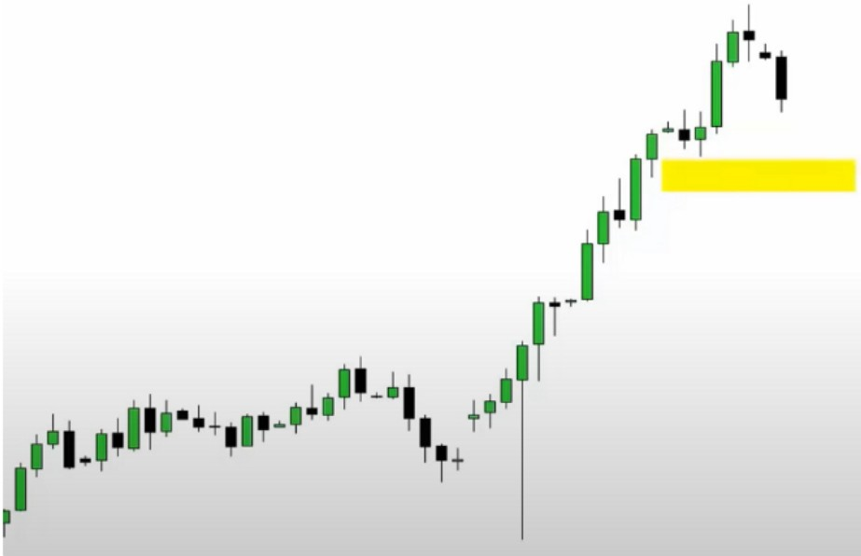

Your stop loss will be below the most recent swing low, and below a specific reference point that ICT will outline in lesson 8

This is a great long term trading entry technique we can use. I plan on using this in the future, i love it

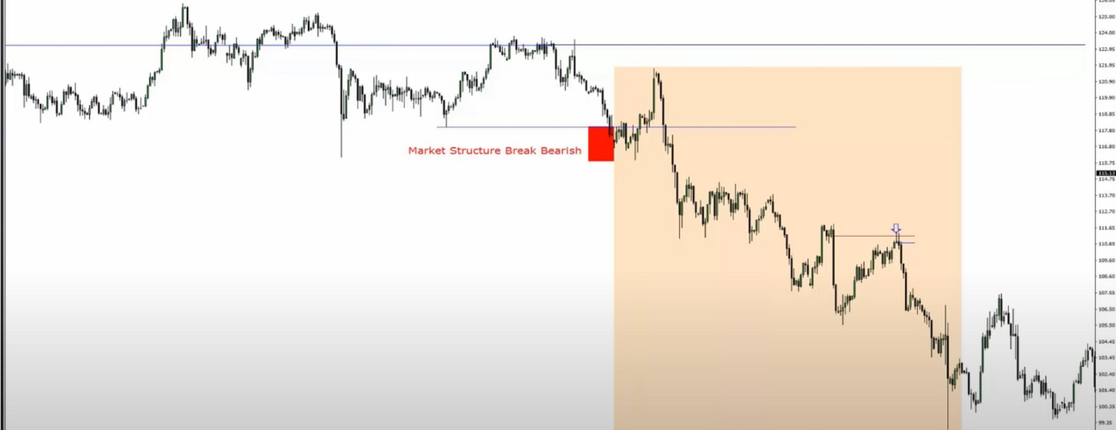

·-- ·-- .._...·-- .. ..... ... --- .,..... ....._.... .......... ----........ ... .., ........·-- ....._ ---·-- ,. ...,,.......... ,.,...,....·-- -- ....... ........ ......

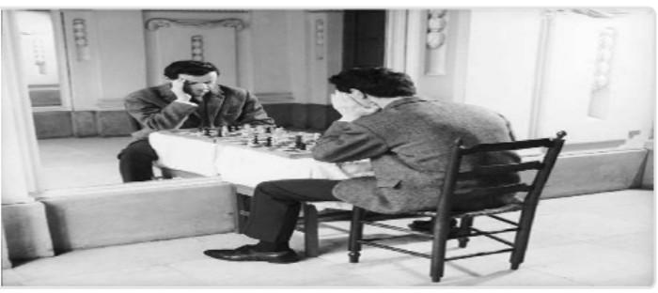Arjo I Twitter, lnstagram I Linktree

Linktree. Make your link do more. https://t.co/HhmmTN1fUI

JavaScript is not available.

*"JI* https://twitter.com/arjoio